<title?>

Marienne Lopez, Hannah Sibayan, Jethro Virtusio
De La Salle University Science and Technology Complex
Binan, Laguna, Philippines
{marienne_lopez, hannah_sibayan, jethro_virtusio}@dlsu.edu.ph

Abstract—This electronic document is a “live” template and already defines the components of your paper [title, text, heads, etc.] in its style sheet. *CRITICAL: Do Not Use Symbols, Special Characters, or Math in Paper Title or Abstract. (Abstract)
Keywords—optical mark recognition (OMR); Python; OpenCV; standardized testing

Introduction
Standardized formal testing is used worldwide as a tool to be able to assess individuals: from students taking exams for their respective subjects to voters choosing their next candidate. In the Philippines, such testing was first implemented in 1924 to assess individuals for a position within government offices [1]. Since then, it was then used in other areas but more prominently in education (e.g. college entrance exams).
Although such exams introduced formality, extracting information from each individual answer sheet still remains a challenge. Optical mark recognition (OMR) was then introduced as an aid through the use of available technologies to do the extraction. Patel et al. [2] mentions three generations of OMR: thermal imaging, traditional scanner, and mobile technology. Due to the throwbacks of both thermal imaging and traditional scanner technologies combined with the increased accessibility of image acquisition devices (e.g. camera) and image analysis technologies (e.g. MatLab), the third and most recent generation, mobile technology, was born. Studies were then created in order to make use of said rapid advances of technology [2,3].
This research paper will feature an OMR analyzer that takes in a picture of a filled OMR sheet as input and output an array of values corresponding to the student’s answer. Said analyzer is intended for OMR sheets used by students in educational institutions to assess their knowledge towards a specific subject.

OMR sheet structure
The OMR sheet to be used for this specific algorithm is shown in Fig. 1 below. Said sheet features two boxes for the student to write in their name and ID number for identification. Below it is an answer area composed of two columns of 15 items each with four circles representing four choices a student may shade in. Beside the answer area is a column of shaded rectangles which will be used by the analyzer to locate the circles. The student is only allowed to shade one circle out of the four possible choices. If a student shades more than one circle for an item, the item will be marked as wrong. Fig. 2. shows a sample input for our OMR sheet analyzer.
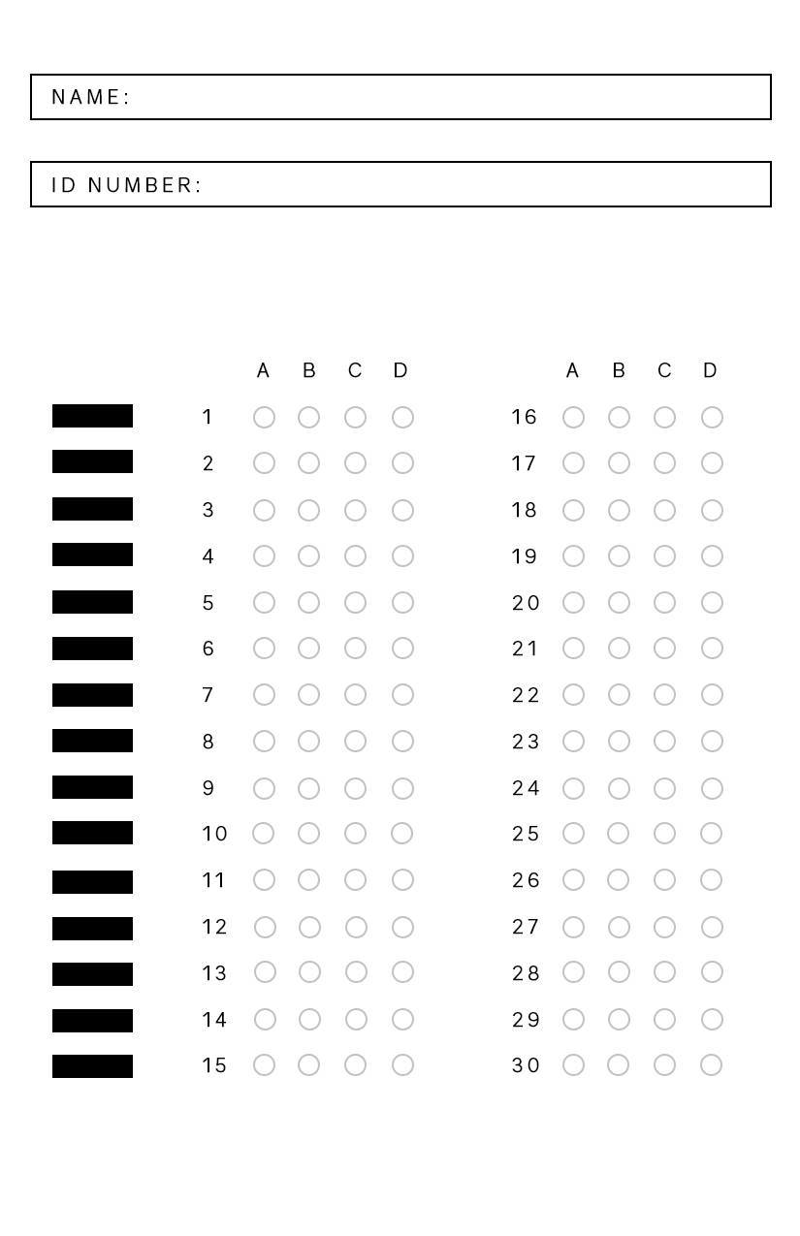
Fig. 1. OMR sheet format used for this research paper

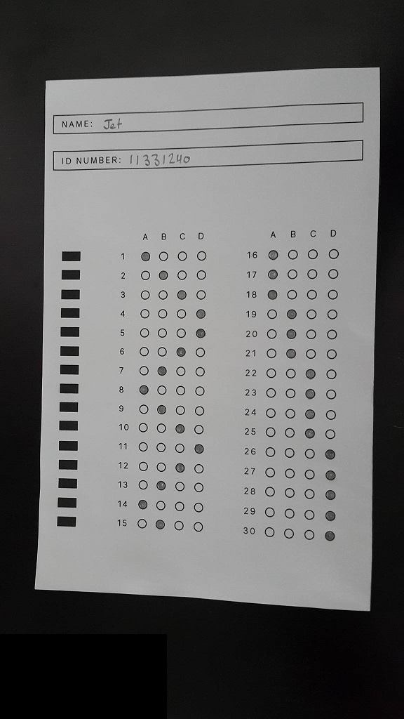
Fig. 2. One possible input image for our OMR analyzer

OMR sheet analyzer algorithm
As explained previously, the OMR sheet analyzer will take a picture of a filled OMR sheet similar to Fig. 2 as input and would output an array of values which represent the student’s answer. The analyzer is divided into three stages: pre-processing, segmentation, and mark analysis. It will be made using Python 2.7 with the help of the imutils [4] and OpenCV for Python [5] libraries.

Pre-processing
In this part of the analyzer, the input image is retrieved and “cleaned” in preparation for the succeeding parts. The first step in this stage is converting it into a gray scale image. Then, a Gaussian filter is applied to the gray scale image to remove noise [6]. After applying the filter on the gray scale image, the Canny edge detection algorithm [7] was then applied to locate all edges and outlines within the image. Using the edge algorithm’s output, four point transform [8] was then applied to remove the OMR sheet background. The output of this stage is the image of the OMR sheet in gray scale.

Segmentation
Using the output of the previous stage of the analyzer, the goal of this stage is to extract the necessary features within the OMR sheet to be used for the Mark Identification stage. The extraction process first starts with applying Otsu’s algorithm [9] on the image of the OMR sheet in gray scale to convert it into a binary image. Afterwards, each feature will be extracted one-by-one: the field for the student’s name, the field for the student’s ID number, the answer area, and shaded rectangles.

Mark Analysis
In this stage, the answer area extracted by the segmentation stage of the analyzer will be used. For each four circles within the answer area, this stage will identify which circle is shaded. This stage will also determine whether the student answered A, B, C, D, none, or invalid for an item. An ‘invalid’ answer would mean that the student shaded two to four of the circles for an item while a ‘none’ meant that the student did not shade any circle for the item. The result is an array that corresponds to what the student’s choices were in the OMR sheet’s answer area.

Performance Evaluation
This is a sample sentence. This is a sample sentence. This is a sample sentence. This is a sample sentence. This is a sample sentence. This is a sample sentence. This is a sample sentence. This is a sample sentence. This is a sample sentence. This is a sample sentence. This is a sample sentence. This is a sample sentence.

Conclusion
This is a sample sentence. This is a sample sentence. This is a sample sentence. This is a sample sentence. This is a sample sentence. This is a sample sentence. This is a sample sentence. This is a sample sentence. This is a sample sentence. This is a sample sentence. This is a sample sentence. This is a sample sentence.

Acknowledgments
We would like to thank Ms. Laguna, our Image Processing (IMAGPRO) professor in helping us understand image processing and giving advice on this research paper. We would also like to thank the makers of Python, OpenCV for Python, and imutils to make image processing possible on today’s laptops and computers.

References
- C. Magno and R. DLC Gonzales, Measurement and Evaluation in the Philippine Higher Education: Trends and Development.
- R. Patel, S. Sanghavi, D. Gupta, and M. S. Raval, CheckIt – A low cost mobile OMR system.
- T. D. Nguyen, Q. H. Manh, P. B. Minh, L. N. Thanh, and T. M. Hoang, Efficient and reliable camera based multiple-choice test grading system.
- K. Elissa, “Title of paper if known,” unpublished.
- R. Nicole, “Title of paper with only first word capitalized,” J. Name Stand. Abbrev., in press.
- Y. Yorozu, M. Hirano, K. Oka, and Y. Tagawa, “Electron spectroscopy studies on magneto-optical media and plastic substrate interface,” IEEE Transl. J. Magn. Japan, vol. 2, pp. 740-741, August 1987 [Digests 9th Annual Conf. Magnetics Japan, p. 301, 1982].
- J. Canny, A computational approach to edge detection.
- Sdfsdf
- N. Otsu, A threshold selection method from gray-level histograms.

